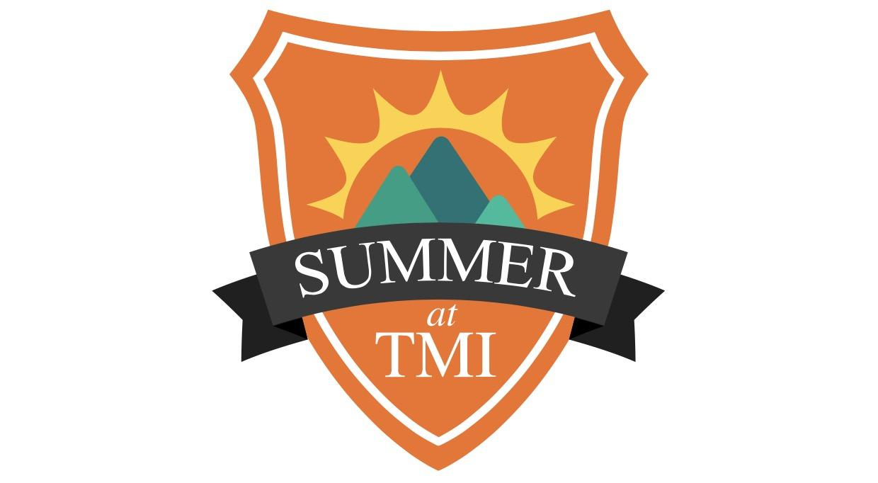

PANTHER DAY CAMP-PROGRAM SPECIALIST (Teacher)

Purpose: to provide for the development and delivery of activities and programs at the day camp tied into the theme of the week. The Program Specialist will organize and administer arts, STEM, nature, athletics, adventure, academic, cooking and other various activities consistent with the theme of that week.
Accountability: the program specialist is accountable to the Director of Auxiliary Programs.
Responsibilities:

- Provide mature and professional leadership to specialized camp programming.

- Supervise campers, guests, volunteers and staff during specialized programs to ensure standards of operation, safety, creativity and structure are implemented.

- Demonstrate patience, enthusiasm, self-control and a sense of humor with all members of the Summer at TMI community.

- To ensure that standards of safety, rules of risk management and structured activity are implemented in your specific area of supervision.

- Work cooperatively with leadership, counselors and support staff to make the summer program run safely and effectively.

- Abide by all camp personnel policies and implement camp goals

- Be responsible for the health, safety, and welfare of campers in general, and specifically campers assigned to your program area.

- Participate in a 2-hour Program Specialist briefing: Sometime during the week of May 22-31, 2024.

- Available employment dates are June 3-July 26, 2024. The expectation is to facilitate offerings 9:30 am -11:00 am (1.5 hrs) and 12:30 pm-2:00 pm (1.5 hrs) Monday – Friday. No camp the week of July 1-5, 2024

- Discounted fees may be available if enrolling your own children in summer camp.
Themes for this coming summer are:

SUPERHERO WEEK
Week One: June 3-7

Unlock your superpowers during this adventure filled week. Discover the hero in you through challenges, adventure, and good deeds. Grab your mask and capes as we launch ourselves into fun and games. We will recognize our local heroes as well as everyday people who make sacrifices to make the world a better place for everyone! Along with discussions on what it means to be a hero, kids will get to design their own superhero logos, make costumes, draw comics and celebrate a Superhero’s birthday.

OUTDOOR ADVENTURE WEEK
Week Two: June 10-14

Experience the great outdoors with nature crafts, tasty concoctions over a fire, lawn games, Science of Nature, and enjoy a camp cookout. Outdoor Adventure Week is an experience that centers on the bonding and memories that are formed with fellow campers and our amazing staff. Through the woods, to camp this week we go! Grab your pack, sunscreen, and comfortable shoes. We're going on an adventure, which includes a nature scavenger hunt, nature crafts and more!

MAD SCIENCE
Week Three: June 17 - 21 (this is a 4-day session, no camp on Wednesday the 19th)

Put on your lab coats as we test different scientific theories and myths. Dive into the world of interactive science where camp is your own laboratory. We'll have all kinds of science activities and experiences, myth-busting, and science facts vs. fiction. Our campers love to build, be creative, and learn "how" and "why" something works. This week will be a combination of games, science discovery, and physical activity. Fizzy, oozing, bubbling experiments are in store for Science Week! Join us as we explore all that science has to offer!

WATER WORKS
Week Four: June 24 - June 28

It’s time to get soaked! Splish and splash through an awesome, fun filled week. Summer is hot in Texas, but you will stay cool with activities like water sponge games, water relays, and more! We will also DIVE into the science behind water! Stay cool this week while playing all sorts of refreshing water games like water balloon toss and launch, bucket brigade, sponge tag, and Water Wars!

NO CAMP July 1-5 in observance of Independence Day

AROUND THE WORLD
Week Five: July 8-12

Get your passport stamped for this global tour of countries, cultures, and people. See what life is like in other parts of the world through multicultural activities, games, meals, projects, and more. Travel the world right from camp and be immersed in culture. With a highlight on multicultural experiences and open-mindedness: enjoy food, games, music, and more from around the world. Have you ever wondered what it would be like to travel the world? Lets GO!

HOGWARTS EXPRESS!
Week Six: July 15 -19

Are you still waiting for your letter to come via owl mail? Well wait no more! You are invited to join us for a week of Wizarding School. Inspired by J.K. Rowling’s Harry Potter series, this camp will transport aspiring wizards to Hogwarts for a week of instruction on Potions class, Care of Magical Creatures, drink butterbeer, make DIY treats, make your own wand, play Quidditch and more! Of course campers will be sorted into houses for some Hogwarts fun!

TREASURE HUNTERS WEEK!
Week Seven: July 22 - 26

Ahoy mateys! Come find the buried treasure at TMI! Campers may learn how to make a wet compass, create their own treasure maps using cartography skills, and be the first to find the hidden treasure! Or excite your campers’ inner Indiana Jones and spend a treasure-themed day in search of The Holy Grail. “Arrrrrgh” you ready to have some fun!? Remember X marks the spot.

